Step 1: Data Ingestion & Tensorization
The Concept: AI cannot see .png files. It only understands high-dimensional matrices called Tensors.
The Code: PairedEnhancementDataset and DataLoader
Before any learning happens, the data must be prepared.
- Reading: Your __getitem__ function uses Image.open().convert("RGB") to read the image into memory.
- Transformation: The transforms.ToTensor() function mathematically converts the pixel values (which range from 0 to 255) into a normalized float tensor ranging from ‭‬ to ‭‬. An image becomes a tensor of shape ‭‬‭‬‭‬ (Channels ‭‬ Height ‭‬ Width).
- Batching: The DataLoader stacks these individual tensors. If your batch size is 8, it creates a 4D tensor of shape ‭‬‭‬‭‬‭‬. This is the exact payload sent to your GPU memory.
Step 2: Feature Extraction (The Forward Pass)
The Concept: Convolutional Neural Networks (CNNs) extract hierarchical patterns from raw pixels.
The Code: out = model(murky) triggering the UWnet class.

When the murky tensor enters model.py, it passes through layers of mathematical algorithms:
- Convolutions (nn.Conv2d): The model applies mathematical filters (kernels) that slide across the image. Early filters compute spatial gradients to find edges; deeper filters find complex textures (like underwater backscatter or color distortion).
- Activation (nn.ReLU): After every convolution, the Rectified Linear Unit function runs:
‭‬‭‬‭‬‭‬‭‬‭‬‭‬‭‬ ‭‬‭‬
This introduces non-linearity, allowing the network to map the highly complex, non-linear physical properties of water light absorption. Without ReLU, the network would just be a simple linear regression model.
- The Residual Bottleneck (torch.cat): Your specific architecture uses a residual connection. Instead of the network trying to reconstruct the entire image from scratch, it calculates the difference (the noise/haze). The code torch.cat((a, input_x), 1) concatenates the learned noise features with the original input, effectively telling the model, "Here is the original image, and here is the exact mathematical subtraction needed to clear it."
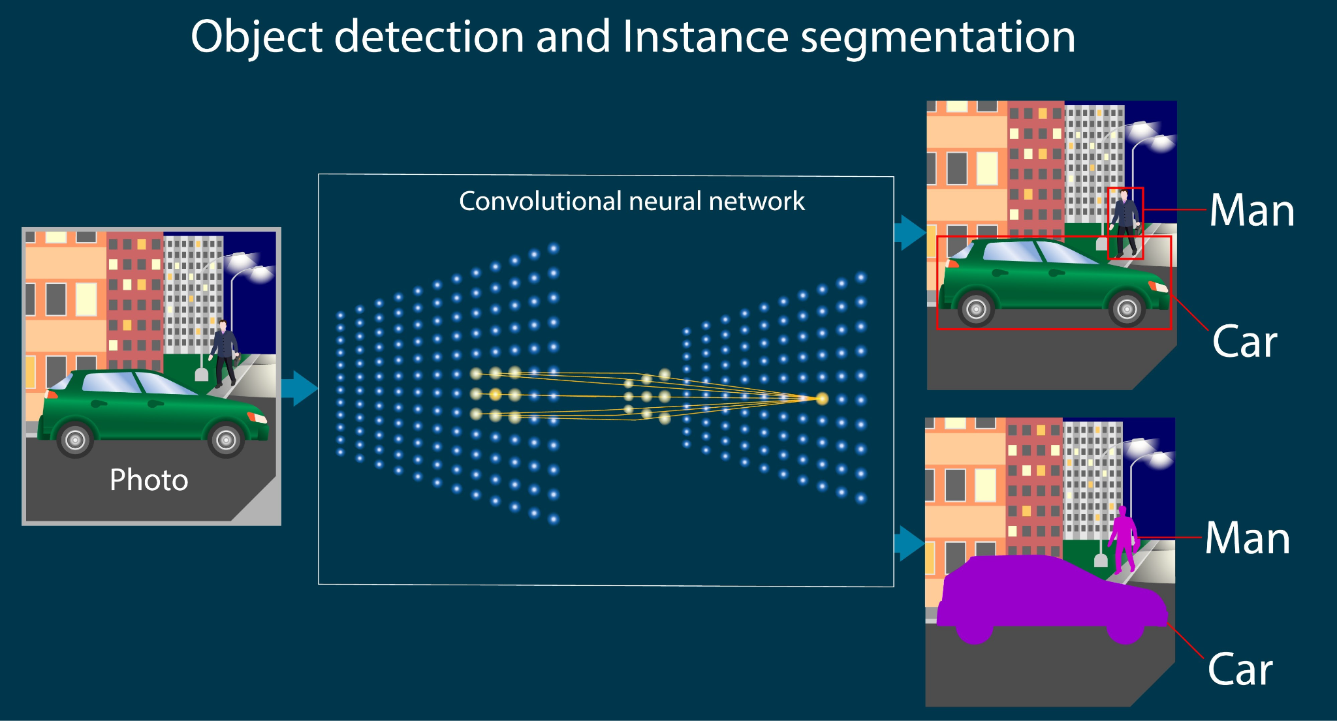
Step 3: Error Calculation (The Loss Function)
The Concept: The model needs a quantitative metric to know how "wrong" its enhanced image is compared to the ground truth.
The Code: loss = criterion(out, clear) using nn.MSELoss().
The output of Step 2 is a prediction (out). The criterion algorithm compares this prediction to the target (clear) pixel-by-pixel.
Mean Squared Error (MSE) runs this equation across the matrices:

‭
‬‭
‬

Where ‭‬ is the actual clear pixel, ‭‬ is the generated pixel, and ‭‬ is the total number of pixels. Squaring the difference heavily penalizes large pixel errors, forcing the model to fix major color imbalances first. The result is a single scalar value representing the total error of that batch.
Step 4: Backpropagation & Optimization (The "Learning")
The Concept: The model must adjust its internal weights to reduce the error calculated in Step 3.
The Code: loss.backward() and optimizer.step().
This is the core of Deep Learning:
- Backpropagation (loss.backward()): PyTorch uses the chain rule of calculus (Autograd) to compute the gradient of the loss with respect to every single weight in the network's convolutional filters. It calculates a tensor of partial derivatives, essentially determining "which weights caused the error, and in which direction should they shift to fix it?"
- Optimization (optimizer.step()): The Adam (Adaptive Moment Estimation) algorithm runs. It updates the weights by taking a step in the opposite direction of the gradient. Adam is highly efficient because it computes individual adaptive learning rates for different parameters based on estimates of first and second moments of the gradients.
- Reset (optimizer.zero_grad()): Crucially, the gradients are cleared before the next batch arrives, ensuring the math starts fresh.
Step 5: The Pipeline Handoff (Stage 2)
The Concept: Semantic Object Detection.
The Code: YOLO(yolo11n.pt) (run during inference/testing, not in your current enhancer training script).
Once the train_enhancer.py loop finishes its 50 epochs, the weights are saved. In the real-world application of your project:
- A raw, murky frame comes in.
- It runs through the frozen, fully-trained UWnet (Step 2) to output a crystal-clear tensor.
- That clear tensor is immediately fed into the YOLO11 model. Because the image is now mathematically free of the "veiling glare" and color distortion, YOLO's bounding box regression algorithms can operate with maximum confidence, successfully identifying objects.

Part 1: The Physics Problem (What the AI is fighting)
When you put a camera underwater, the image degrades rapidly. You need to explain to your mentors that the AI is solving a specific mathematical degradation modeled by the Jaffe-McGlamery Underwater Optical Model.
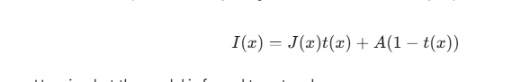
- $I(x)$ The Murky Image: What your camera actually sees (The input tensor).
- $J(x)$ The Clear Image: The true, perfect scene (What your AI is trying to guess).
- $t(x)$ The Transmission Map (Wavelength Attenuation): Water is a filter. It absorbs Red light within the first 5 meters, leaving only Blue and Green. This creates the severe color distortion.
- $A(1 - t(x))$ The Backscatter (Veiling Glare): Floating particles (sand, plankton) reflect the sun directly back into the lens, creating a hazy fog that destroys contrast.

Part 2: How Shallow-UWnet Solves It (The Deep Learning)
When your RTX GPU processes the murky image, here is the step-by-step logic happening inside model.py.

1. Why "Shallow"? (A great talking point for mentors)
Standard U-Nets are very "deep" (they have dozens of layers) because they are built for medical imaging.
- The Problem with Deep Networks: Every time an image goes through a pooling layer (shrinking), it loses high-frequency spatial details (sharp edges, tiny textures).
- The Shallow Advantage: By intentionally making the network shallower (only 3 blocks, as seen in your code UWnet(num_layers=3)), the model preserves the crisp edges of underwater structures while still having enough mathematical depth to learn the color correction. It is also computationally lighter, meaning it could eventually run live on an underwater drone.

2. The Convolutional Encoder (Understanding the Haze)
The first half of the network breaks the image down into feature maps using 3x3 Convolutional Kernels.
- It looks at the RGB channels and notices the massive bias in the Blue and Green matrices.
- It mathematically isolates the Veiling Glare by finding areas of low contrast and high brightness.

3. Skip Connections (The Secret Weapon)
As the network compresses the image to understand the overall lighting, it would normally forget the fine details.
- Your UWnet uses Skip Connections. It draws a wire directly from the raw input layers and concatenates (torch.cat) that data with the deep layers.
- What you tell the mentors: "The skip connections allow the network to combine its high-level understanding of the water's color cast with the low-level sharpness of the original pixels, ensuring the output is perfectly crisp."

4. The Loss Function (Guiding the Math)
During training, the model outputs a guess and compares it to the clear image using Mean Squared Error (MSE).
- If the model outputs an image that still has a green tint, the MSE penalty will be massive.
- Through Backpropagation, the model adjusts the weights in its convolutional filters, literally learning to "subtract Green" and "boost Red" based on the specific patterns of the water it is looking at.
- 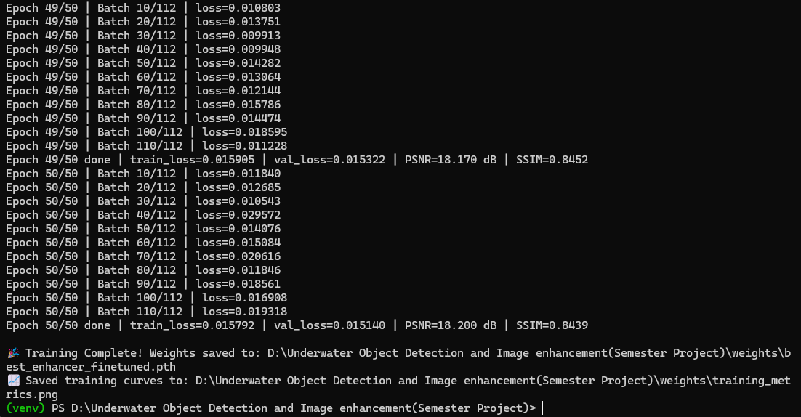

Metrics
